Information on the Jobticket/
Company Ticket for new employees

Welcome to Freie Universität Berlin!

For many years, employees and civil servants of Freie Universität have been able to benefit from a framework agreement between Freie Universität Berlin and the S-Bahn Berlin GmbH to obtain a public transport ticket at a reduced price.

Employees can currently choose between two company ticket products: The VBB-Company Ticket (“Environmental Card”) or the
Deutschlandticket-Job.

Please see overleaf for more information on both options.

Please also refer to the staff circular 02/2023 - Mobility at Freie Universität Berlin (available in German only). All civil servants, in particular those entitled to the capital city allowance, will find further important information in the staff circular regarding the subsidy for a VBB-Company Ticket.

Deutschlandticket-Job
Conditions
- Valid for all public transport systems throughout Germany as well as local and regional trains (excludes long-distance IC, EC, and ICE trains)
- The ticket is not transferable to another person
- No additional persons are allowed to travel with you free of charge
- The ticket is available as a card
- Can be cancelled monthly (Deadline: 10th of the previous month)
If you take out a subscription for the Deutschlandticket-Job (with S-Bahn Berlin), Freie Universität Berlin will pay you a tax-free employer's allowance of 15,75 € per month. In addition, the S-Bahn Berlin GmbH grants a public transport discount of 3,15 € on the fare of the Deutschlandticket. The total price paid by the employee amounts to 44,10 €.
The tax-free employer's allowance will be transferred to your bank account monthly along with your salary and is shown separately on your pay slip.
The employer's allowance can only be granted if a corresponding company ticket subscription has been taken out with the S-Bahn Berlin.
It’s not necessary to notify the Personnel Division after a subscription has been taken out as this happens automatically.
If you have any questions regarding your Deutschlandticket-Job contract, please contact the S-Bahn Berlin subscription service.
VBB-Company Ticket
Information about the different tariffs can be found here or while the order:
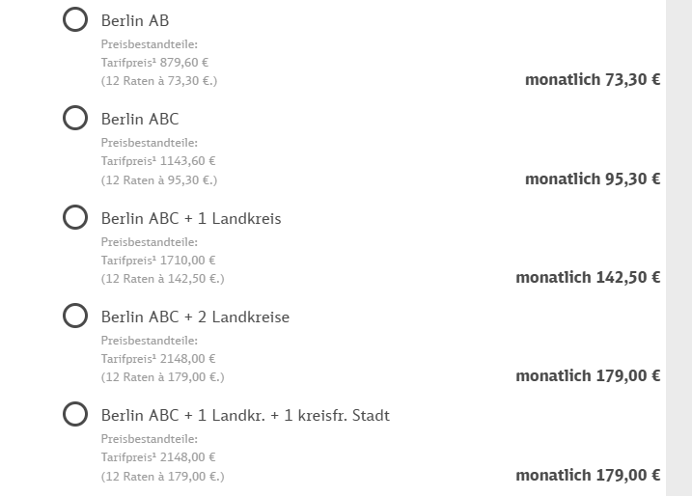
The minimum contract length is 12 months. A subscription can only be taken out if your duration of employment at FUB is will last at least 12 months from the day you register for the Company Ticket.
Conditions
- Valid in the chosen fare zones
- The ticket is not transferable to another person
- Cheaper than purchasing a monthly ticket every month
- Additional persons can be taken along for free at certain times
- Automatically renews after 12 months
- The ticket is available as a card

If you take out a subscription for the VBB-Company Ticket, Freie Universität Berlin will pay you a monthly a tax-free employer subsidy of 15,00 € per month. In addition, S-Bahn Berlin GmbH grants a public transportation discount of 8,00 € on the fare (for Berlin AB). The total price paid by the employee amounts to 50,30 € for the fare zones A and B.
The tax-free employer's allowance will be transferred to your bank account monthly along with your salary and is shown separately on your pay slip.
The employer's allowance can only be granted if a corresponding company ticket subscription has been taken out with the S-Bahn Berlin.
It’s not necessary to notify the Personnel Division after a subscription has been taken out as this happens automatically.
If you have any questions regarding your VBB-Company Ticket contract, please contact the S-Bahn Berlin subscription service.

You already have a monthly ticket subscription?
If you already have a monthly subscription and would like to switch to the Deutschlandticket-Job or VBB-Company Ticket, you must first order the Deutschlandticket-Job or the VBB-Company Ticket and then cancel your old subscription.

How to sign up for the Deutschlandticket-Job and the VBB-Company Ticket
Please use the online portal provided by S-Bahn Berlin GmbH for the registration and administration of subscriptions:

https://firmenticket.sbahn.berlin/de/
Username: 30761858@bestellung
Password: Bestellung!2020

The online portal is only available in German. FUB’s Welcome Service can assist you during the registration process.

Any subscriptions taken out by the 15th of a given month will allow you to use the Deutschlandticket-Job or the VBB-Company Ticket by the 1st of the next month.

After booking you will receive an e-mail from S-Bahn Berlin. This e-mail contains a link to confirm your booking. If you do not confirm your booking within 24 hours, no further processing of your application will occur. Be sure to check your spam folder!

After the booking has been confirmed, your request will be forwarded to the Jobticket Office at FUB. Here, your booking will be checked and approved and forwarded to the Personnel Division for payment of the tax-free employer subsidy.

Changing your contact details
Please contact the S-Bahn Berlin subscription service or use the company ticket portal.

Cancelling your VBB-Company Ticket or Deutschlandticket-Job
You no longer need your ticket?

Use the online portal cancel your ticket (www.firmenticket.sbahn.berlin/de/) or inform the S-Bahn Berlin in writing of your cancellation.

Please also let us know the date when of the subscription will end: jobticket@personal.fu-berlin.de

End of employment at FUB
If your employment ends or is not extended, the entitlement to the company ticket also ends. You are therefore obligated to terminate the contract with the S-Bahn Berlin for the company ticket in due time.

